1970
What is meant by the lattice energy of an ionic compound? What quantities need to be determined and how are they used to calculate the lattice energy of an ionic compound.
Answer:
Lattice energy - quantity of energy released in the formation of one mole of an ionic solid from its separated gaseous ions.
The energy quantities needed to be determined:
sublimation of solid metal
ionization of gaseous atomic metal (ionization energy)
dissociation of gaseous non-metal
ion formation by gaseous atomic non-metal (electron affinity)
They are used with Hess’s Law to determine the combination of gaseous ions. This is the Born-Haber Cycle.

1971
Solve the following problem
AgBr(s) → Ag⁺(aq) + Br⁻(aq) K_{sp} = 3.3×10⁻¹³
Ag⁺(aq) + 2 NH₃(aq) → Ag(NH₃)₂⁺(aq) K = 1.7×10⁺⁷
(a) How many grams of silver bromide, AgBr, can be dissolved in 50 milliliters of water?
(b) How many grams of silver bromide can be dissolved in 50 milliliters of 10 molar ammonia solution?
Answer:
(a) [Ag⁺][Br⁻] = K_{sp} = 3.3×10⁻¹³ = X²
X = 5.7×10⁻⁷ M = [Ag⁺] = mol/L AgBr that dissolve
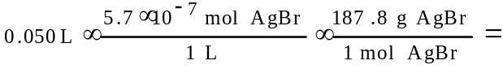
= 5.4×10⁻⁶ g AgBr
(b) AgBr(s) → Ag⁺(aq) + Br⁻(aq) K_{sp} = 3.3×10⁻¹³
Ag⁺(aq) + 2 NH₃(aq) → Ag(NH₃)₂⁺(aq) K = 1.7×10⁺⁷
------------------------------------------
AgBr + 2 NH₃ → Ag(NH₃)₂⁺ + Br⁻
K = K_{sp}×K = 5.6×10⁻⁶
[Ag(NH₃)₂⁺] = [Br⁻] = X M; [NH₃] = (10 - 2X) M
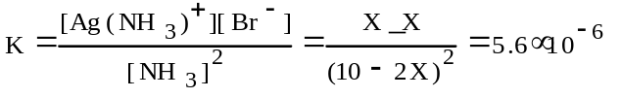
X = 2.4×10⁻² M = [Br⁻] = mol/L dissolved AgBr
(2.4×10⁻² mol/L)(187.8 g/mol)(0.050 L) = 0.22 g AgBr

1971
Molarity and molality are two ways of expressing concentration.
(a) Clearly distinguish between them
(b) Indicate an experimental situation where expressing concentrations as molarity is particularly appropriate.
(c) Indicate an experimental situation where expressing concentration as molality is particularly appropriate.
Answer:
(a) molarity (M) - molar concentration; composition or concentration of a solution expressed as number of moles of solute per liter of solution.
molality (m) - solution concentration expressed as number of moles of solute per kilogram of solvent.
many possibilities, examples:
(b) Acid - base titrations
(c) Molecular weight determination by freezing point depression change.

1972 D
(a) How many moles of Ba(IO₃)₂ is contained in 1.0 liter of a saturated solution of this salt at 25°. K_{sp} of Ba(IO₃)₂ = 6.5×10⁻¹⁰
(b) When 0.100 liter of 0.060 molar Ba(NO₃)₂ and 0.150 liter of 0.12 molar KIO₃ are mixed at 25°C, how many milligrams of barium ion remains in each milliliter of the solution? Assume that the volumes are additive and that all activity coefficients are unity.
Answer:
(a) Ba(IO₃)₂ ↔ Ba²⁺ + 2 IO₃⁻
K_{sp} = [Ba²⁺][IO₃⁻]² = 6.5×10⁻¹⁰
[Ba²⁺] = X; [IO₃⁻] = 2X; (X)(2X)² = 6.5×10⁻¹⁰
X = 5.5×10⁻⁴ M = mol/L of dissolved Ba(IO₃)₂
(b) initial mol Ba²⁺ = (0.060 mol/L)(0.100L) = 0.0060 mol
initial mol IO₃⁻ = (0.150L)(0.120 mol/L) = 0.0180 mol
after reaction, essentially all Ba²⁺ reacts while IO₃⁻ = {0.0180 - (2)(0.0060)} mol = 0.0060 mol/0.250 L = 0.024M [IO₃⁻]
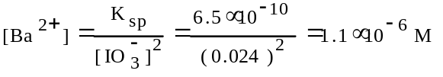
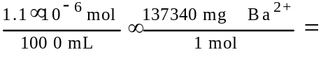
= 1.5×10⁻⁴ mg / mL Ba²⁺

1973 D
The molar solubility of silver bromide is diminished by the addition of a small amount of solid potassium bromide to a saturated solution. However, the molar solubility of silver bromide is increased by the addition of solid potassium nitrate, a salt whose ions are not common to those of silver bromide.
Explain these experimental observations in terms of the principles involved.
Answer:
AgBr(s) ↔ Ag⁺(aq) + Br⁻(aq); As KBr dissolves, the concentration of Br⁻ ions increase and force the equilibrium to shift to the left (LeChatelier’s principle) where the concentrations of the ions in solution decrease and less can dissolve.
The diverse (“uncommon”) ion effect – “the salt effect”. As the total ionic concentration of a solution increases, interionic attractions become more important. Activities become smaller than the stoichiometric or measured concentrations. For the ions involved in the solution process this means that a higher concentration must appear in solution before equilibrium is established. - the solubility must increase.

1974 D
Two beakers, one containing 100 milliliters of a 0.10 molal solution of sucrose (a nonvolatile nonelectrolyte) the other containing 100 milliliters of pure water, are placed side by side in a closed system, such as under a bell jar. Explain in terms of the principles involved what changes, if any, occur to bring the system to equilibrium.
Answer:
(1) Volume of sugar solution increases; (2) volume of pure water decreases; (3) water beaker finally empty.
Raoult’s Law, vapor pressure and volatility
Description of process (rates of vaporization and condensation)

1975 D
Alcohol dissolves in water to give a solution that boils at a lower temperature than pure water. Salt dissolves in water to give a solution that boils at a higher temperature than pure water. Explain these facts from the standpoint of vapor pressure.
Answer:
An alcohol-water solution has a higher than normal (pure water) vapor pressure because alcohol is a volatile solute and contributes substantially to the vapor of the solution. The higher the vapor pressure, the lower the boiling point. A salt-water solution has a lower than normal vapor because salt is a non-volatile solute and solute-solvent interaction decrease the vapor of the solution, the lower the vapor pressure, the higher the boiling point.

1976 B
(a) Calculate the molality of a 20.0 percent by weight aqueous solution of NH₄Cl. (Molecular weight: NH₄Cl = 53.5)
(b) If this NH₄Cl solution is assumed to be ideal and is completely dissociated into ions, calculate the pressure of this solution at 29.0°C.
(c) Actually a solution of NH₄Cl of this concentration is not ideal. Calculate the apparent degree of dissociation of the NH₄Cl if the freezing point of this solution is -15.3°C? (Molal freezing point constant = 1.86°C)
Answer:
(a) 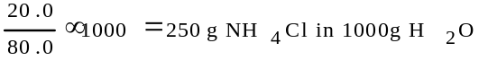
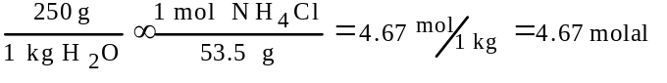
(b) P₁ = (P°)(X₁)
mol ions = (2)(4.67 mol) = 9.34 mol
1 kg water = 55.6 mol water
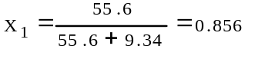
P₁= (29.8 mm Hg)(0.856) = 25.5 mm Hg
(c) Assume no dissociation.
ΔT = k_{f}m = (1.86)(4.67) = 8.69°C
i = 15.3 / 8.69 = 1.76
(1.76 - 1.00)(100) = 76% dissociated

1977 D
The solubility of Zn(OH)₂ is not the same in the following solutions as it is in pure water. In each case state whether the solubility is greater or less than that in water and briefly account for the change in solubility.
(a) 1-molar HCl (c) 1-molar NaOH
(b) 1-molar Zn(NO₃)₂ (d) 1-molar NH₃
Answer:
(a) greater: Zn(OH)₂(s) + 2 H⁺ → Zn²⁺ + 2 H₂O
(b) lower: increased [Zn²⁺] decreases [OH⁻] and decreases the amount of Zn(OH)₂ in solution. K_{sp} =[Zn²⁺][OH⁻]²
(c) greater: Zn(OH)₂(s) + 2 OH⁻ → Zn(OH)₄²⁻ (Can also site common ion effect)
(d) greater: Zn(OH)₂(s) + 4 NH₃ → Zn(NH₃)₄²⁺ + OH⁻

1977 D
The state of aggregation of solids can be described as belonging to the following four types:
(1) ionic (3) covalent network
(2) metallic (4) molecular
For each of these types of solids, indicate the kinds of particles that occupy the lattice points and identify forces among these particles. How could each type of solid be identified in the laboratory?
Answer:
 | Particles | Binding Forces | Experimental Identification
ionic | + & - ions | electrostatic attraction | conductivity of fused salt
metallic | + ions | electrostatic attraction between ions and electrons | conductivity of the solid
covalent network | atoms | covalent bonds | high melting pt., extreme hardness, etc.
molecular | molecules | van der Waals | low melting pt., non-conductivity of fused salt, etc.

1978 D
The freezing point and electrical conductivities of three aqueous solutions are given below.
Solution Freezing Electrical
(0.010 molal) Point Conductivity
sucrose -0.0186°C almost zero
formic acid -0.0213°C low
sodium formate -0.0361°C high
Explain the relationship between the freezing point and electrical conductivity for each of the solutions above. Account for the differences in the freezing points among the three solutions.
Answer:
sucrose
a non electrolyte
0.010 mol/kg lowers freezing point 0.0186°C
formic acid
a weak electrolyte; low conductance as a result of low ion concentration
m_{total} > 0.010 molal due to partial ionization and ΔT_{f} somewhat greater than 0.0186°C
sodium formate
a salt and strong electrolyte
approximately 100% dissociation into ions, m_{total} approaching 0.02 molal

1979 A
A saturated solution of lead iodate in pure water has a lead ion concentration of 4.0×10⁻⁵ mole per liter at 20°C.
(a) Calculate the value for the solubility-product constant of Pb(IO₃)₂ at 25°C.
(b) Calculate the molar solubility of Pb(IO₃)₂ in a 0.10 molar Pb(NO₃)₂ solution at 25°C.
(c) To 333 milliliters of a 0.120-molar Pb(NO₃)₂ solution, 667 milliliters of 0.435-molar KIO₃ is added. Calculate the concentrations of Pb²⁺ and IO₃⁻ in the solution at equilibrium at 25°C.
Answer:
(a) Pb(IO₃)₂(s) ↔ Pb²⁺ + 2 IO₃⁻
K_{sp} = [Pb²⁺][IO₃⁻]² = (4.0×10⁻⁵)(8.0×10⁻⁵)²
= 2.6×10⁻¹³
(b) [Pb²⁺] = (0.10 + X) M ≈ 0.10 M
[IO₃⁻]² = (2X) M
K_{sp} = [Pb²⁺][IO₃⁻]² = 2.6×10⁻¹³ = (0.10)(2X)²
X = 8.1×10⁻⁷M = mol Pb(IO₃)₂ dissolved per L solution.
(c) initial mol Pb²⁺ = 0.0400 mol
initial mol IO₃⁻ = 0.290 mol
ppt must occur; after ppt, mole IO₃⁻ in solution = (0.290 - 0.080) mol = 0.210 mol
[IO₃⁻] = 0.210 M since the volume is 1.00 L
K_{sp} = [Pb²⁺][IO₃⁻]² = 2.6×10⁻¹³ = [Pb²⁺](0.210)²
[Pb²⁺] = 5.8×10⁻¹² M

1980 B
(a) A solution containing 3.23 grams of an unknown compound dissolved in 100.0 grams of water freezes at -0.97°C. The solution does not conduct electricity. Calculate the molecular weight of the compound. (The molal freezing point depression constant for water is 1.86°C kg mole⁻¹)
(b) Elemental analysis of this unknown compound yields the following percentages by weight H=9.74%; C=38.70%; O=51.56%. Determine the molecular formula for the compound.
(c) Complete combustion of a 1.05 gram sample of the compound with the stoichiometric amount of oxygen gas produces a mixture of H₂O(g) and CO₂(g). What is the pressure of this gas mixture when it is contained in a 3.00 liter flask at 127°C?
Answer:
(a) ΔT_{f} = k_{f}m; 0.97°C = (1.86°Cm⁻¹)(m)
m = 0.52 mol solute/kg solvent
In this solution, 3.23 g solute in 100.0 g water or 32.3 g solute in 1 kg of water
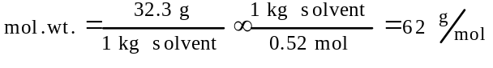
(b) 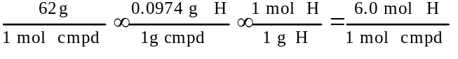
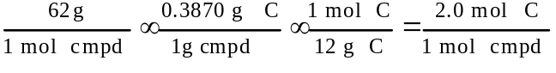
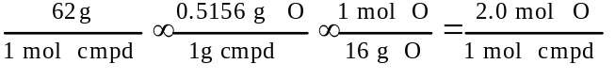
= C₂H₆O₂
(c) 2 C₂H₆O₂ + 5 O₂ → 6 H₂O(g) + 4 CO₂(g)
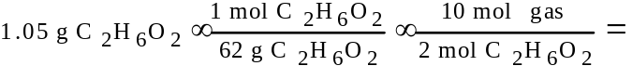
= 0.0847 mol gas
P = (nRT) / V
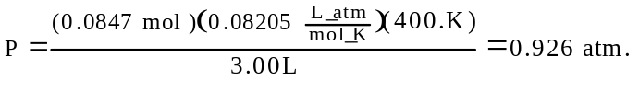

1980 D
Account for the differences in solubility described in each of the following experimental observations:
(a) BaCO₃, BaSO₃, and BaSO₄ are only slightly soluble in water, but the first two dissolve in HCl solution whereas BaSO₄ does not.
(b) CuS cannot be dissolved by warm dilute HCl but it does dissolve in warm dilute HNO₃.
(c) AgCl, Hg₂Cl₂ and PbCl₂ are only slightly soluble in water, but AgCl does dissolve in ammonia solution whereas the other two do not.
(d) Fe(OH)₃ and Al(OH)₃ are only slightly soluble in water, but Al(OH)₃ dissolves in concentrated NaOH whereas Fe(OH)₃ does not.
Answer:
(a) BaCO₃(s) ↔ Ba²⁺ + CO₃²⁻
BaSO₃(s) ↔ Ba²⁺ + SO₃²⁻
BaSO₄(s) ↔ Ba²⁺ + SO₄²⁻
Dissolving takes place if equilibrium is shifted to the right.
CO₃²⁻ + H⁺ → HCO₃⁻ + H⁺ → H₂O + CO₂(g)
SO₃²⁻ + H⁺ → HSO₃⁻ + H⁺ → H₂O + SO₂(g)
In these two cases, equilibrium is shifted to the right by the production of a removed product (a gas).
SO₄²⁻ + H⁺ do not react since SO₄²⁻ is a weak Bronsted base.
(b) Warm dilute HNO₃ oxidizes S²⁻ to S° (or higher). This reaction shifts the equilibrium between CuS(s) and its ions toward the ions.
(c) AgCl(s) + 2 NH₃ → [Ag(NH₃)₂]⁺ + Cl⁻
silver ions complex with ammonia to form the soluble [Ag(NH₃)₂]⁺, neither Hg₂²⁺ nor Pb²⁺ form such complexes.
(d) Al(OH)₃(s) + OH⁻ → Al(OH)₄⁻ (or similar)
Al(OH)₃ is amphoteric. The product is a hydroxoaluminate ion, Fe(OH)₃ is not amphoteric.

1984 C
Give a scientific explanation for the following observations. Use equations or diagrams if they are relevant.
(a) It takes longer to cook an egg until it is hard-boiled in Denver (altitude 1 mile above sea level) than it does in New York City (near sea level).
(b) Burn coal containing a significant amount of sulfur leads to ôacid rain.ö
(c) Perspiring is a mechanism for cooling the body.
(d) The addition of antifreeze to water in a radiator decreases the likelihood that the liquid in the radiator will either freeze or boil.
Answer:
(a) Water boils at a lower temperature in Denver than in NYC because the atmospheric pressure is less at high altitudes. At a lower temperature, the cooking process is slower, so the time to prepare a hard-boiled egg is longer.
(b) S + O₂ → SO₂ (as coal is burned)
SO₂ + H₂O → H₂SO₃ (in the atmosphere)
H₂SO₃ is sulfurous acid.
(c) Vaporization or evaporation of sweat from the skin is an endothermic process and takes heat from the body and so cool the skin.
(d) Colligative properties, which depend on the number of particles present, are involved.
Solute (the antifreeze) causes the lowering of the vapor pressure of the solvent. When the vapor pressure of the solvent is lowered, the freezing point is lowered and the boiling point is raised.

1985 B
The formula and the molecular weight of an unknown hydrocarbon compound are to be determined by elemental analysis and the freezing-point depression method.
(a) The hydrocarbon is found to contain 93.46 percent carbon and 6.54 percent hydrogen. Calculate the empirical formula of the unknown hydrocarbon.
(b) A solution is prepared by dissolving 2.53 grams of p-dichlorobenzene (molecular weight 147.0) in 25.86 grams of naphthalene (molecular weight 128.2). Calculate the molality of the p-dichlorobenzene solution.
(c) The freezing point of pure naphthalene is determined to be 80.2°C. The solution prepared in (b) is found to have an initial freezing point of 75.7°C. Calculate the molal freezing-point depression constant of naphthalene.
(d) A solution of 2.42 grams of the unknown hydrocarbon dissolved in 26.7 grams of naphthalene is found to freeze initially at 76.2°C. Calculate the apparent molecular weight of the unknown hydrocarbon on the basis of the freezing-point depression experiment above.
(e) What is the molecular formula of the unknown hydrocarbon?
Answer:
(a) Assume 100. g sample of the hydrocarbon
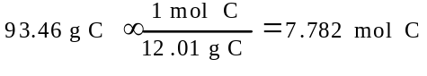
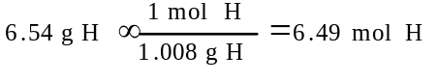
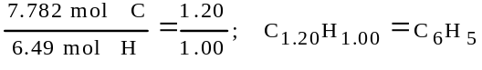
(b)
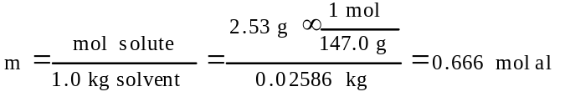
(c) ΔT_{f} = (80.2 - 75.7)°C = 4.5°C
k_{f} = ΔT_{f} /m = 4.5°C / 0.666 molal = 6.8°C/molal
(d) ΔT_{f} = (80.2 - 76.2)°C = 4.0°C
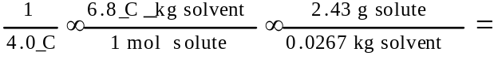
=154 g/mol
(e) C₆H₅ = 77
# empirical units/mol = 154/77 = 2
molecular formula = (C₆H₅)₂ = C₁₂H₁₀

1986 D
Give a scientific explanation for each of the following observations. Use equations or diagrams if they seem relevant.
(a) Graphite is used to make electrodes, while diamond, another allotrope of carbon, is a very poor conductor of electricity.
(b) Putting rock salt on an icy driveway melts the ice even when the air temperature is -10°C.
(c) [question and answer in the GASES section]
(d) Carbon dioxide, rather than a stream of water, should be used to extinguish an oil fire.
Answer:
(a) Distinction or correctly implied distinction between the structures of graphite and diamond.
Freedom of movement of electrons in graphite resulting from the structure.
(b) The rock salt forms a concentrated solution with very little water from the ice. The solution now has a freezing point lower than the temperature of the ice, therefore, the ice melts.
(c) [question and answer in the GASES section]
(d) Carbon dioxide is more dense than air and so pushes the air away from the fire.
Water is more dense than the oil and so ends up below the oil, leaving the oil still in contact with the air; or the hot burning oil quickly vaporizes the water creating steam that spatters the oil into the air.

1987 D
In 1884 the Swedish chemist Svante Arrhenius proposed that salts dissociate into two or more separate, independent, ionic fragments when they dissolve in water.
(a) Give one piece of experimental evidence that more than 1 mole of particles is formed when 1 mole of a salt dissolves in water.
(b) Give one piece of experimental evidence that the particles formed when a salt dissolves in water are charged.
(c) Explain why the heat of neutralization is always the same when 1 mole of any monoprotic strong acid reacts with enough strong base to form a neutral solution.
(d) Explain why hydrogen chloride, HCl, dissociated when it dissolves in water but not when it dissolves in benzene.
Answer:
(a) The freezing point depression (or any colligative effect) that occurs when a mole of a salt is dissolved is greater than when a mole of a non-dissociated substance is dissolved. (The greater the number of solute particles the greater the colligative effect.)
(b) The solution of a salt conducts electricity.
(c) Every neutralization between a strong acid and a strong base involves the same reaction:
H⁺(aq) + OH⁻(aq) → H₂O
since both the strong acid and the strong base are completely dissociated. Spectator ions have no appreciable effect.
(d) Because of the polar nature of water, it is capable of solvating the ions that result from the dissociation, whereas the nonpolar benzene interacts very weakly with these ions. OR
Because of the greater dielectric constant of water, it is better able to separate the ions.

1988 D
The normal boiling and freezing points of argon are 87.3 K and 84.0 K, respectively. The triple point is at 82.7 K and 0.68 atmosphere.
(a) Use the data above to draw a phase diagram for argon. Label the axes and label the regions in which the solid, liquid and gas phases are stable. On the phase diagram, show the position of the normal boiling point.
(b) Describe any changes that can be observed in a sample of solid argon when the temperature is increased from 40 K to 160 K at a constant pressure of 0.50 atmosphere.
(c) Describe any changes that can be observed in a sample of liquid argon when the pressure is reduced from 10 atmospheres to 1 atmosphere at a constant temperature of 100 K, which is well below the critical temperature.
(d) Does the liquid phase of argon have a density greater than, equal to, or less than the density of the solid phase? Explain your answer, using information given in the introduction to this question.
Answer:
(a)
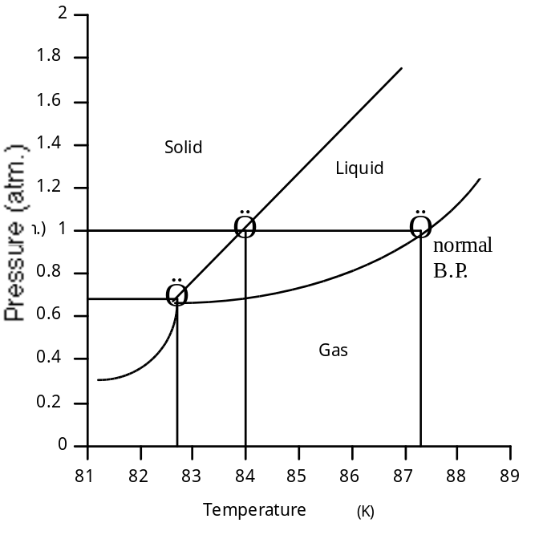
(b) The argon sublimes.
(c) The argon vaporizes.
(d) The liquid phase is less dense than the solid phase. Since the freezing point of argon is higher than the triple point temperature, the solid-liquid equilibrium line slopes to the right with increasing pressure. Thus, if a sample of liquid argon is compressed (pressure increased) at constant temperature, the liquid becomes a solid. Because increasing pressure favors the denser phase, solid argon must be the denser phase.

1989 D
Consider three unlabeled bottles, each contain small pieces of one of the following metals.
- Magnesium
- Sodium
- Silver
The following reagents are used for identifying the metals.
- Pure water
- A solution of 1.0 molar HCl
- A solution of concentrated HNO₃
(a) Which metal can be easily identified because it is much softer than the other two? Describe a chemical test that distinguishes this metal from the other two, using only one of the reagents above. Write a balanced chemical equation for the reaction that occurs.
(b) One of the other two metals reacts readily with the HCl solution. Identify the metal and write the balanced chemical equation for the reaction that occurs when this metal is added to the HCl solution. Use the table of standard reduction potentials (attached) to account for the fact that this metal reacts with HCl while the other does not.
(c) The one remaining metal reacts with the concentrated HNO₃ solution. Write a balanced chemical equation for the reaction that occurs.
(d) The solution obtained in (c) is diluted and a few drops of 1 M HCl is added. Describe what would be observed. Write a balanced chemical equation for the reaction that occurs.
Answer:
(a) Sodium is softest of the three.
Na added to water → gas and base
Na + H₂O → H₂ + NaOH
(b) Mg reacts with HCl. Mg + 2 H⁺ → Mg²⁺ + H₂
Reduction potentials, E°: Mg = -2.37v; Ag = + 0.80v. Mg, not Ag, reacts with HCl
(c) Ag + 4 H⁺ + NO₃⁻ → 3 Ag⁺ + NO + 2 H₂O OR
Ag + 2 H⁺ + NO₃⁻ → Ag⁺ + NO₂ + H₂O
(d) A white precipitate forms: Ag⁺ + Cl⁻ → AgCl(s)

1990 A
The solubility of iron(II) hydroxide, Fe(OH)₂, is 1.43×10⁻³ gram per litre at 25°C.
(a) Write a balanced equation for the solubility equilibrium.
(b) Write the expression for the solubility product constant, K_{sp}, and calculate its value.
(c) Calculate the pH of a saturated solution of Fe(OH)₂ at 25°C.
(d) A 50.0 millilitre sample of 3.00×10⁻³ molar FeSO₄ solution is added to 50.0 millilitres of 4.00×10⁻⁶ molar NaOH solution. Does a precipitate of Fe(OH)₂ form? Explain and show calculations to support your answer.
Answer:
(a) Fe(OH)₂ → Fe²⁺ + 2 OH⁻
(b) 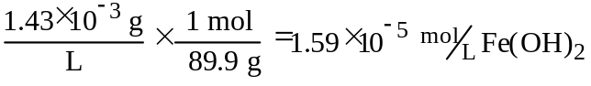
= 1.59×10⁻⁵ M = [Fe²⁺]
= 3.18×10⁻⁵ M = [OH⁻]
K_{sp} = [Fe²⁺][OH⁻]² = (1.59×10⁻⁵)(3.18×10⁻⁵)²
= 1.61×10⁻¹⁴
(c) 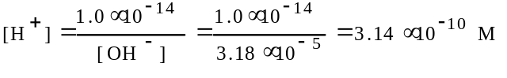
pH = -log[H⁺] = 9.50
OR
pOH = -log[OH⁻] = -log(3.18×10⁻⁸) = 4.50
pH = 14 - pOH = 9.50
(d) 50.0 mL of 3.00×10⁻³ M Fe²⁺ diluted of 100.0 mL = 1.50×10⁻³ M Fe²⁺
50.0 mL of 4.00×10⁻⁶ M OH⁻ diluted of 100.0 mL = 2.00×10⁻⁶ M OH⁻
Q = [Fe²⁺][OH⁻]² = (1.50×10⁻³)(2.00×10⁻⁶)²
= 6.00×10⁻¹⁵
Precipitate will NOT form since Q < K_{sp}

1993 A
Elemental analysis of an unknown pure substance indicated that the percent composition by mass is as follows.
Element | Percent by Mass
Carbon | 49.02%
Hydrogen | 2.743%
Chlorine | 48.23%
A solution that is prepared by dissolving 3.150 grams of the substance in 25.00 grams of benzene, C₆H₆, has a freezing point of 1.12°C. (The normal freezing point of benzene is 5.50°C and the molal freezing-point depression constant, K_{f}, for benzene is 5.12°C/molal.)
(a) Determine the empirical formula of the unknown substance.
(b) Using the data gathered from the freezing-point depression method, calculate the molar mass of the unknown substance.
(c) Calculate the mole fraction of benzene in the solution described above.
(d) The vapor pressure of pure benzene at 35°C is 150. millimeters of Hg. Calculate the vapor pressure of benzene over the solution described above at 35°C.
Answer:
(a) moles / 100 g C H Cl
49.02/12.01 2.743/1.008 48.23/35.45
= 4.081 = 2.722 = 1.360
mol ratio 3 2 1
empirical formula: C₃H₂Cl
(b) ΔT_{f} = (K_{f})(m)
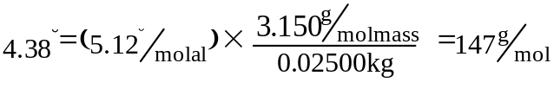
(c) mol fraction = mol benzene / total mol
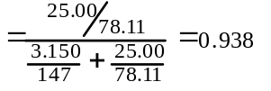
(d) vapor pressure = mol fraction × P_{o}
= (0.938)(150 mm) = 141 mm Hg

1994 D (Required)
Discuss the following phenomena in terms of the chemical and physical properties of the substances involved and general principles of chemical and physical change.
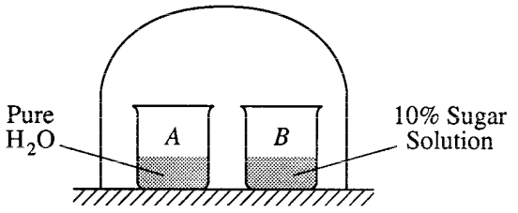
(a) As the system shown above approaches equilibrium, what change occurs to the volume of water in beaker A? What happens to the concentration of the sugar solution in beaker B? Explain why these changes occur.
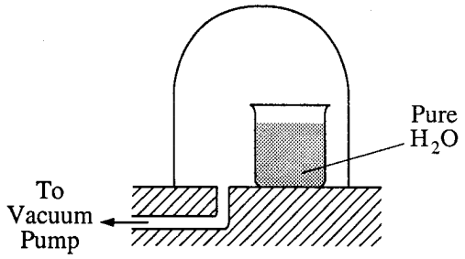
(b) A bell jar connected to a vacuum pump is shown above. As the air pressure under the bell jar decreases, what behavior of water in the beaker will be observed? Explain why this occurs.
(c) [see Redox section]
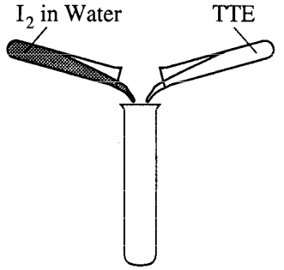
(d) A water solution of I₂ is shaken with an equal volume of a nonpolar solvent such as TTE (tri-chlorotrifluoroethane). Describe the appearance of this system after shaking. (A diagram may be helpful.) Account for this observation.
Answer:
(a) volume of water decreases while the concentration of sugar solution decreases.
Pure water has a higher vapor pressure than does the 10% sugar solution and when equilibrium is reached the water will evaporate and the solution will increase in volume.
(b) The water will boil when the pressure in the bell jar reaches the vapor pressure of the water. Boiling occurs when the vapor pressure of the liquid is in equilibrium with the pressure above the liquid.
(d) (i) Water and TTE will form separate layers because the polar water is not miscible with the non-polar TTE.
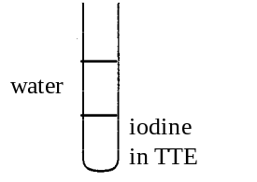
(ii) The TTE will be the bottom layer because its density is greater than the water.
(iii) The non-polar iodine will dissolve better in the non-polar TTE and form a pinkish-purple tint.

1994 D
For each of the following, use appropriate chemical principles to explain the observation.
(a) Sodium chloride may be spread on an icy sidewalk in order to melt the ice; equimolar amounts of calcium chloride are even more effective.
(b) At room temperature, NH₃ is a gas and H₂O is a liquid, even though NH₃ has a molar mass of 17 grams and H₂O has a molar mass of 18 grams.
(c) C (graphite) is used as a lubricant, whereas C (diamond) is used as an abrasive.
(d) Pouring vinegar onto the white residue inside a kettle used for boiling water results in a fizzing/bubbling phenomenon.
Answer:
(a) NaCl(s) → Na⁺(aq) + Cl⁻(aq)
CaCl₂(s) → Ca⁺(aq) + 2 Cl⁻(aq)
The freezing point of an aqueous solution is lower than the freezing point of water. A higher molality of a solution lowers the freezing point more and an equimolar amount of the two solids gives a larger molal solution from the calcium chloride as illustrated by the above equations.
(b) Water is more polar than ammonia creating stronger attractions (IMF) between molecules and making it a liquid.
(c) Diamond, the hardest naturally occurring substance, has each carbon atom surrounded by a tetrahedral arrangement of other carbon atoms (see drawing). The network solid structure is stabilized by covalent bonds, formed by the overlap of sp³ hybridized carbon atomic orbitals. A diamond has uniform very strong bonds in all directions in the crystal.
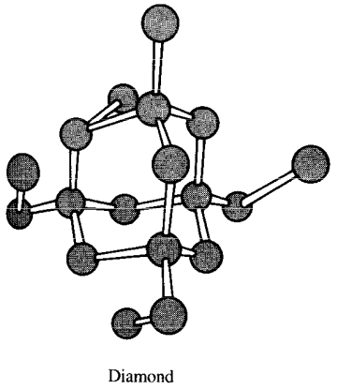
Graphite has a different kind of bonding based on layers of carbon atoms arranged in fused six-member rings (see drawing). Each carbon atom in a layer is surrounded by three other carbons in a trigonal planar arrangement with 120° bond angles. The slipperiness is caused by noting that graphite has very strong bonds within layers but little bonding between the layers which allows the layers to slide past one another quite readily.
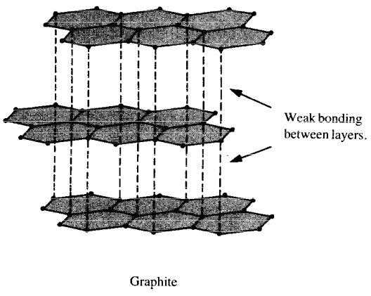
(d) Calcium and magnesium carbonates are left behind from the evaporation of hard water. These carbonates decompose and release carbon dioxide gas when reacted with the acetic acid in the vinegar.
CaCO₃(s) + MgCO₃(s) + CH₃COOH(aq) → Ca²⁺(aq) + Mg²⁺(aq) + H₂O(l) + CO₂(g) + CH₃COO⁻(aq)

1995 D
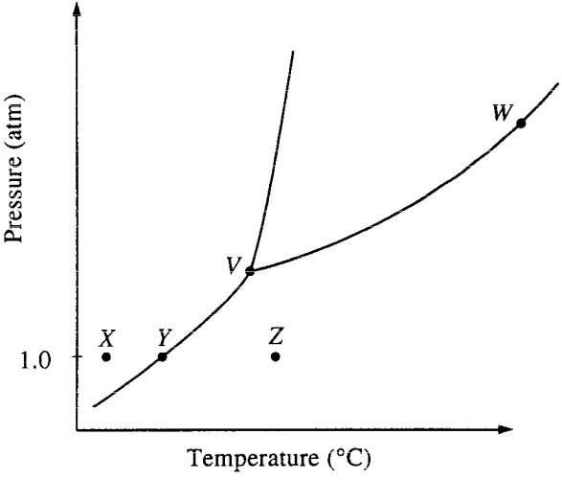
The phase diagram for a pure substance is shown above. Use this diagram and your knowledge about changes of phase to answer the following questions.
(a) What does point V represent? What characteristics are specific to the system only at point V?.
(b) What does each point on the curve between V and W represent?
(c) Describe the changes that the system undergoes as the temperature slowly increases from X to Y to Z at 1.0 atmosphere.
(d) In a solid-liquid mixture of this substance, will the solid float or sink? Explain.
Answer:
(a) Triple point. All three states of the substance coexist (equilibrium); the solid and the liquid have identical vapor pressures.
(b) Curve VW represents the equilibrium between the liquid and its vapor. Along this line the liquid will be boiling. The points represent the vapor pressure of the liquid as a function of temperature.
(c) At point X the substance is a solid, as its temperature increases (at constant pressure), at point Y the solid is in equilibrium with its vapor and will sublime. From point Y to Z it exist only as a vapor.
(d) Sink. A positive slope of the solid-liquid line indicates that the solid is denser than its liquid and, therefore, will sink.

1995 D (repeated in the thermo section)
Lead iodide is a dense, golden yellow, slightly soluble solid. At 25°C, lead iodide dissolves in water forming a system represented by the following equation.
PbI₂(s) ↔ Pb²⁺ + 2 I⁻ ΔH = +46.5 kilojoules
(a) How does the entropy of the system PbI₂(s) + H₂O(l) change as PbI₂(s) dissolves in water at 25°C? Explain
(b) If the temperature of the system were lowered from 25°C to 15°C, what would be the effect on the value of K_{sp}? Explain.
(c) If additional solid PbI₂ were added to the system at equilibrium, what would be the effect on the concentration of I⁻ in the solution? Explain.
(d) At equilibrium, ΔG = 0. What is the initial effect on the value of ΔG of adding a small amount of Pb(NO₃)₂ to the system at equilibrium? Explain.
Answer:
(a) Entropy increases. At the same temperature, liquids and solids have a much lower entropy than do aqueous ions. Ions in solutions have much greater “degrees of freedom and randomness”.
(b) K_{sp} value decreases. K_{sp} = [Pb²⁺][I⁻]². As the temperature is decreased, the rate of the forward (endothermic) reaction decreases resulting in a net decrease in ion concentration which produces a smaller K_{sp} value.
(c) No effect. The addition of more solid PbI₂ does not change the concentration of the PbI₂ which is a constant (at constant temperature), therefore, neither the rate of the forward nor reverse reaction is affected and the concentration of iodide ions remains the same.
(d) ΔG increases. Increasing the concentration of Pb²⁺ ions causes a spontaneous increase in the reverse reaction rate (a “shift left” according to LeChatelier’s Principle). A reverse reaction is spontaneous when the ΔG>0.

1996 B
Concentrated sulfuric acid (18.4-molar H₂SO₄) has a density of 1.84 grams per milliliter. After dilution with water to 5.20-molar, the solution has a density of 1.38 grams per milliliter and can be used as an electrolyte in lead storage batteries for automobiles.
(a) Calculate the volume of concentrated acid required to prepare 1.00 liter of 5.20-molar H₂SO₄.
(b) Determine the mass percent of H₂SO₄ in the original concentrated solution.
(c) Calculate the volume of 5.20-molar H₂SO₄ that can be completely neutralized with 10.5 grams of sodium bicarbonate, NaHCO₃.
(d) What is the molality of the 5.20-molar H₂SO₄?
Answer:
(a) M₁V₁ = M₂V₂ ; (5.20 M)(1.00 L) = (18.4 M)(V₂)
V₂ = 0.283 L
(b) 18.4 mol/1 L × 98.1 g H₂SO₄/1 mol = 1805 g H₂SO₄
1 L × 1.84 g/1 mL × 1000 mL/1 L = 1840 g solution
mass % = 1805 g/1840 g × 100 = 98.1%
(c) 2 NaHCO₃ + H₂SO₄ → 2 H₂O + Na₂SO₄ + 2 CO₂
10.5 g NaHCO₃ × 1 mol NaHCO₃/84.0 g NaHCO₃ × 1 mol H₂SO₄/2 mol NaHCO₃ × 1 L/5.20 mol H₂SO₄ = 0.0120 L
(d) molality = mol solute/1 kg solvent
5.20 mol/1 L × 98.1 g H₂SO₄/1 mol = 510 g H₂SO₄
1 L × 1.38 g/1 mL × 1000 mL/1 L = 1380 g solution
1380 g solution - 510 g H₂SO₄ = 870 g solvent
5.20 mol H₂SO₄/0.870 kg solvent = 5.98 m

1998 A (Required)
Solve the following problem related to the solubility equilibria of some metal hydroxides in aqueous solution.
(a) The solubility of Cu(OH)₂(s) is 1.72×10⁻⁶ gram per 100. milliliters of solution at 25°C.
(i) Write the balanced chemical equation for the dissociation of Cu(OH)₂(s) in aqueous solution.
(ii) Calculate the solubility (in moles per liter) of Cu(OH)₂ at 25°C.
(iii) Calculate the value of the solubility-product constant, K_{sp}, for Cu(OH)₂ at 25°C.
(b) The value of the solubility-product constant, K_{sp}, for Zn(OH)₂ is 7.7×10⁻¹⁷ at 25°C.
(i) Calculate the solubility (in moles per liter) of Zn(OH)₂ at 25°C in a solution with a pH of 9.35.
(ii) At 25°C, 50.0 milliliters of 0.100-molar Zn(NO₃)₂ is mixed with 50.0 milliliters of 0.300-molar NaOH. Calculate the molar concentration of Zn²⁺(aq) in the resulting solution once equilibrium has been established. Assume that volumes are additive.
Answer
(a)i Cu(OH)₂ → Cu²⁺ + 2 OH⁻
ii 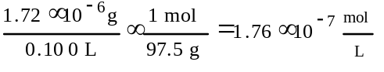
iii K_{sp} = [Cu²⁺][OH⁻]²
= [1.76×10⁻⁷][3.53×10⁻⁷]² = 2.20×10⁻²⁰
(b)i Zn(OH)₂ → Zn²⁺ + 2 OH⁻
K_{sp} = [Zn²⁺][OH⁻]²
pH 9.35 = pOH 4.65; [OH⁻] = 10^{-pOH}
[OH⁻] = 10^{-4.65} = 2.24×10⁻⁵ M
[Zn²⁺] = solubility of Zn(OH)₂ in ^{mol}/_{L}
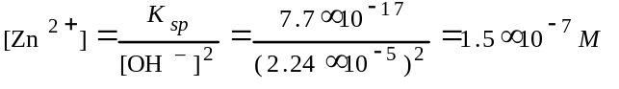
ii [Zn²⁺]_{init} = 0.100M × 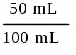 = 0.0500 M
[OH⁻]_{init} = 0.300M × = 0.150 M
X = conc. loss to get to equilibrium
K_{sp} = 7.7×10⁻¹⁷ = (0.0500 - X)(0.150 - 2X)²
[Zn²⁺] = 0.0500 - X = 3.1×10⁻¹⁴M

1998 B
An unknown compound contains only the three elements C, H, and O. A pure sample of the compound is analyzed and found to be 65.60 percent C and 9.44 percent H by mass.
(a) Determine the empirical formula of the compound.
(b) A solution of 1.570 grams of the compound in 16.08 grams of camphor is observed to freeze at a temperature 15.2 Celsius degrees below the normal freezing point of pure camphor. Determine the molar mass and apparent molecular formula of the compound. (The molal freezing-point depression constant, K_{â}, for camphor is 40.0 kg•K•mol⁻¹.)
(c) When 1.570 grams of the compound is vaporized at 300°C and 1.00 atmosphere, the gas occupies a volume of 577 milliliters. What is the molar mass of the compound based on this result?
(d) Briefly describe what occurs in solution that accounts for the difference between the results obtained in parts (b) and (c).
Answer
(a) 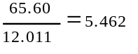 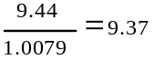 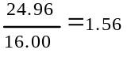
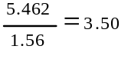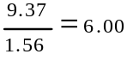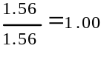
(C_{3.5}H₆O₁)₂ = C₇H₁₂O₂
(b) ΔT_{FP} = k_{â}m =k_{â}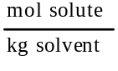 = k_{â}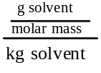
molar mass = 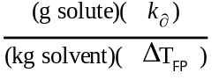
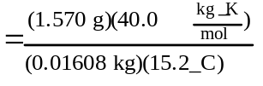 = 257 ^{g}/_{mol}
C₇H₁₂O₂ = 128 ^{g}/_{mol} ; ²⁵⁷/₁₂₈ = 2
∴, (C₇H₁₂O₂)₂ = C₁₄H₂₄O₄
(c) PV = 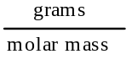RT
molar mass = 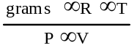
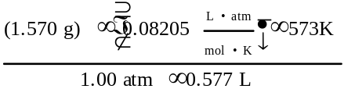= 128 ^{g}/_{mol}
(d) since the apparent molar mass from freezing point change is twice that determined by the vapor, the molecules of the compound must associate in camphor to form dimers, OR the compound must dissociate in the gas phase.

1998 D
Answer each of the following using appropriate chemical principles.
(a) Why does it take longer to cook an egg in boiling water at high altitude than it does at sea level?
Answer
(a) At a high altitude the pressure is lower and the boiling point of water is lower. Since the temperature of the boiling water is less, it takes longer to cook the egg.

1999 D
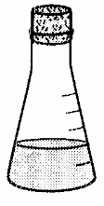
0.10M 0.10M 0.10M 0.10M
NaF MgCl2 C2H5OH CH3COOH
Answer the following questions, which refer to the 100 mL samples of aqueous solutions at 25ºC in the stoppered flasks shown above.
(a) Which solution has the lowest electrical conductivity? Explain.
(b) Which solution has the lowest freezing point? Explain.
(c) Above which solution is the pressure of the water vapor greatest? Explain.
(d) Which solution has the highest pH? Explain.
Answer
(a) 0.10 M C2H5OH, flask 3. It is the only solute that is not partially or wholly ionized (or dissociated) since it is a covalently bonded molecule. Ions are needed to conduct an electric current.
(b) 0.10 M MgCl2, flask 2. The freezing point depression is a colligative property, and the magnesium chloride dissolves to give 3 particles (ions) for each dissolved MgCl2. In effect, the solution acts more like a 0.3 M solution, the van’t Hoff factor.
(c) 0.10 M C2H5OH, flask 3. The vapor pressure is also a colligative property. Since the other solutions give an effective concentration greater than their measured molarity, the non-ionized ethyl alcohol will allow the water to vaporize the easiest.
(d) 0.10 M NaF, flask 1. HF is a weak acid and the F– ion will react with water to produce hydroxide ions and a pH greater than 7.
F– + H2O ó HF + OH–
The MgCl2 is essentially neutral as well as the C2H5OH, the CH3COOH is a weak acid and will give a pH less than 7.

